**What is AJAX?**

AJAX, or Asynchronous JavaScript and XML, is a new web development technique for creating interactive web applications. In and of itself, AJAX is not a programming language; Rather, it can create better and faster more interactive web applications with the help of XML, HTML, CSS, and Java Script (“What is AJAX?”, 2018). Specifically, AJAX combines a built-in browser XMLHttpRequest object, which gets data from a web server, and displays or uses the data with JavaScript and the HTML DOM (“AJAX Introduction”, 2018).

**What are the main characteristics of this technology?**

The main characteristic, and benefit of using, AJAX technology is that parts of a web page can be updated without reloading the entire page; This creates a more seamless user-friendly experience (“AJAX Introduction”, 2018) because the web page gets updated asynchronously in the background. Behind the scenes, a web page can request and receive data from a server after the page is loaded, at which point the page can be updated (“AJAX Introduction”, 2018).

**What are the existing standards that AJAX is based on?**

AJAX does not work independently and is not a programming language. Instead, it is implemented with other Open Standard technologies to create interactive web pages. Here is a list of open standards, which AJAX is based upon:

* JavaScript - This is the scripting language that makes everything happen dynamically. When an event occurs in a web page, a JavaScript function gets called to perform some changes.
* DOM - This is the graphical interface representation of XML or HTML document content.
* CSS - Styles the content and can be changed by JavaScript.
* XMLHttpRequest - A JavaScript object that sends and requests data in XML format from the server in the background asynchronously.

(adapted from “What is AJAX?”, 2018).

**Explain how AJAX works.**

While AJAX works in the background to update web pages, traditional web applications transmit data using synchronous requests, meaning that when a user fills out a form and hits submit, they will get directed to a new page with the new information from the server. Instead, when the user hits submit with AJAX, JavaScript will make a request to the server, interpret the results, and update the current screen seamlessly (“What is AJAX?” (2018).

The graphic below shows the differences between AJAX and traditional web pages:

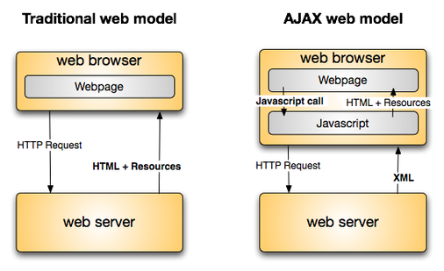

(Scott, January 5, 2007).

For clarity, here is a list of the steps involved in making AJAX work in web pages:

1. An event occurs in a web page (the page is loaded, a button is clicked)

2. An XMLHttpRequest object is created by JavaScript

3. The XMLHttpRequest object sends a request to a web server

4. The server processes the request

5. The server sends a response back to the web page

6. The response is read by JavaScript

7. Proper action (like page update) is performed by JavaScript

(excerpted from “AJAX Introduction”, 2018).

**Can AJAX replace PHP?**

AJAX is gaining momentum in the web development industry, with several frameworks and tool kits emerging. However, AJAX is incompatible with some browsers an is supported by JavaScript, which can be hard to maintain and debug (“What is AJAX?”, 2018). Nevertheless, these are not reasons why AJAX will not replace PHP. The simple fact of the matter is that AJAX is not meant to be a replacement for PHP. PHP cannot update a web page asynchronously without AJAX; Instead, AJAX can update parts of a web page whereas the server script will be written in PHP (“AJAX Introduction”, 2018).

**References**

“AJAX Introduction” (2018). W3schools. Retrieved from <https://www.w3schools.com/xml/ajax_intro.asp>

Scott, T. (January 5, 2007). “AJAX what is it? (it’s not DHTML)”. Retrieved from <https://derivadow.com/2007/01/05/ajax-what-is-it-its-not-dhtml/>

“What is AJAX?” (2018). TutorialsPoint. Retrieved from <https://www.tutorialspoint.com/ajax/what_is_ajax.htm>